Name | Shubhan Singh
UID no. | 2022300118
Experiment No. | 2 (Control structures)

AIM: | To apply various control structures to solve given problems.
Program 1
PROBLEM STATEMENT : | Take two numbers as input and calculate their LCM and GCD (HCF).
ALGORITHM: | Step 1: START  Step 2: Read two numbers as input A and B.  Step 3: Find the bigger of the two numbers  Step 4: Set a temporary variable temp equal to the lower value.  Step 5: Take modulus of both numbers with the temporary variable.  Step 6: If any of the operations does not return zero, decrement temp by 1, and return to Step 5.  Step 7: When both operations return 0, the value of temp is the GCD of the two numbers.  Step 8: Calculate LCM using the formula LCM=A*B/GCD  Step 9: Print GCD and LCM as output.  Step 10: END.
FLOWCHART: | 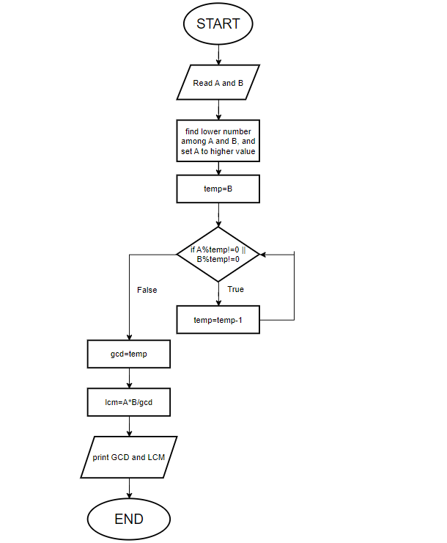
PROGRAM: | #include<stdio.h>  int main(){  int a,b,temp,gcd,lcm;  printf("enter two numbers\n");  scanf("%d %d",&a,&b);  if(a<b){  temp=a;  a=b;  b=temp;}//a is bigger  temp=b;  printf("temp=%d\n",temp);  while( a%temp!=0 || b%temp!=0 ){  temp--;  }  gcd=temp;  lcm=a*b/gcd;  printf("the GCD of the two numbers=%d, and their LCM=%d",gcd,lcm);  return 0;  }
RESULT: 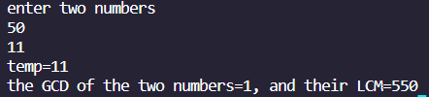
Program 2
PROBLEM STATEMENT : | Write a program to convert a decimal number to binary or convert a binary number to decimal
ALGORITHM: | Step 1: Start  Step 2: Determine whether to convert input to binary or decimal.  Step 3: Read input number.  If converting to binary,  Step 4a: If number is not divisible by 2, binary=binary+x , here, binary is a variable initialized to 0.  Step 5a: divide the number by 2  Step 6a: multiply x by 10  Step 7a: return to step 4a if number is greater than or equal to 1.  Step 8a: Print the value of binary.  If converting to decimal,  Step 4b: Read input binary number A.  Step 5b: declare a variable i initialized to 0.  Step 6b: if A%10 equals 1, dec=dec+10^i ,here, dec is a variable initialized to 0  Step 7b: divide number by 10.  Step 8b: If number is not equal to 0, return to step 6b.  Step 9b: Print value of dec.  Step 10: END
FLOWCHART: | 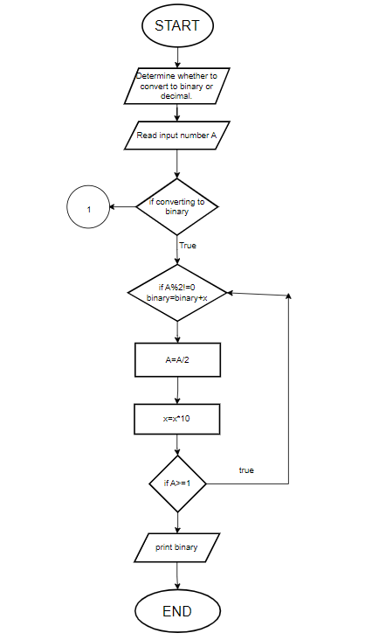  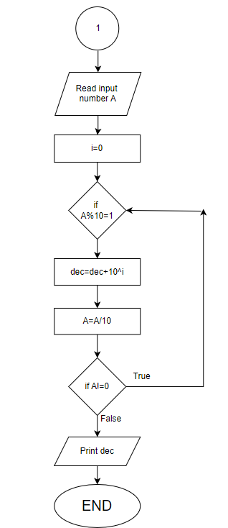
PROGRAM: | #include<stdio.h>  #include<math.h>  int main(){  int i,n,bin=0,temp,dec=0,x=1,binary=0;  printf("enter 1 for decimal to binary conversion, 2 for binary to decimal conversion\n");  scanf("%d",&i);  if(i==1){//decimal to binary  printf("enter non negative decimal number\n");  scanf("%d",&n);  while(n>=1){  if(n%2==1){  binary=binary+x;  }  n=n/2;  x=x*10;  }  printf("the binary form of the number is: %d",binary);  }  else if(i==2){//binary to decimal  printf("enter binary number\n");//any number other than 0 will be considered 1  scanf("%d",&bin);  for(i=0;i>=0;i++){  if(bin%10==1){dec=dec+pow(2,i);}  bin=bin/10;  if(bin==0){break;}  }  printf("the decimal form of the given number is: %d",dec);  }  else{//invalid choice(not 1 or 2)  printf("invalid input\n");  }  return 0;  }
RESULT: 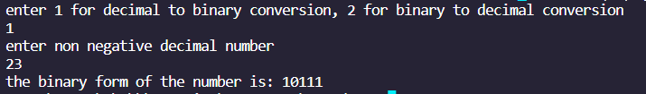
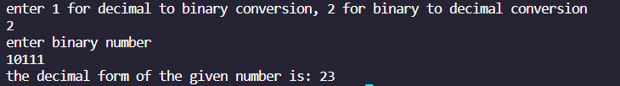
Program 3
PROBLEM STATEMENT: | Twin primes are consecutive odd numbers, both of which are prime numbers. Write a program which inputs two positive integers A and B and outputs all twin primes in range A to B.
ALGORITHM: | Step 1: START  Step 2: Read input for range A to B.  Step 3: If A<=2, A=3  Step 4: For i=A,  Step 5: for j=2,  Step 6: if i%j equals 0, increment flag variable count and go to step 9. (count is initialised at 2)  Step 7: increment j.  Step 8: if j<i/2, return to step 6.  Step 9: for x=2,  Step 10: if (i+2)%x equals 0, increment flag variable count and go to step 13. (count is initialised at 2)  Step 11: increment x.  Step 12: if x<i/2+1 , return to step 10.  Step 13: if count equals 2, print that i and i+2 are a pair of twin primes.  Step 14:increment i  Step 15: if i<=b/2, return to step 5.  Step 16: END
FLOWCHART: | Didn’t know how to draw this flowchart.
PROGRAM: | #include<stdio.h>  int main(){  int a,b,j,x,i;  printf("Enter the range\n");  scanf("%d %d",&a,&b);  if(a<0 && b<=0){  printf("invalid input");  return 0;  }  printf("All pairs of twin primes in this range are: ");  if(a<=2){  a=3;  }  if(a>2){  for(i=a;i<=b-2;i++){  int count=2;  for(j=2;j<i/2;j++){  if(i%j==0){count++;break;}  }  for(x=2;x<(i/2+1);x++){  if((i+2)%x==0){count++;break;}  }  if(count==2){printf("[%d,%d]\n",i,i+2);};  }  }  return 0;  }
RESULT: 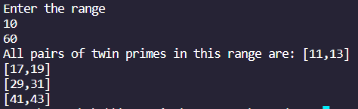
Program 4
PROBLEM STATEMENT: | Write a program to find out whether a number is kaprekar or not. Consider an n-digit number k. Square it and add the right n digits to the left n or n-1 digits. If the resultant sum is k, then k is called a Kaprekar number.
ALGORITHM: | Step 1: START  Step 2: read number from input  Step 3: square the number and store it in sq.  Step 4: make a temporary variable temp=sq  Step 5: if temp != 0, increment flag variable digits, else jump to step 7.(digits is initialized at 0)  Step 6: temp=temp/10, return to step 5  Step 7: left=digits/2  Step 8: temp=sq  Step 9: temp=sq/10^(digits-left)  Step 10: l=temp.  Step 11: temp=temp*10^(digits-left)  Step 12: r=sq-temp  Step 13: kap=r+l  Step 14: if kap equals the original input number, print that it is a kaprekar number  Step 15: else print it is not a kaprekar number.  Step 16: END
FLOWCHART: | 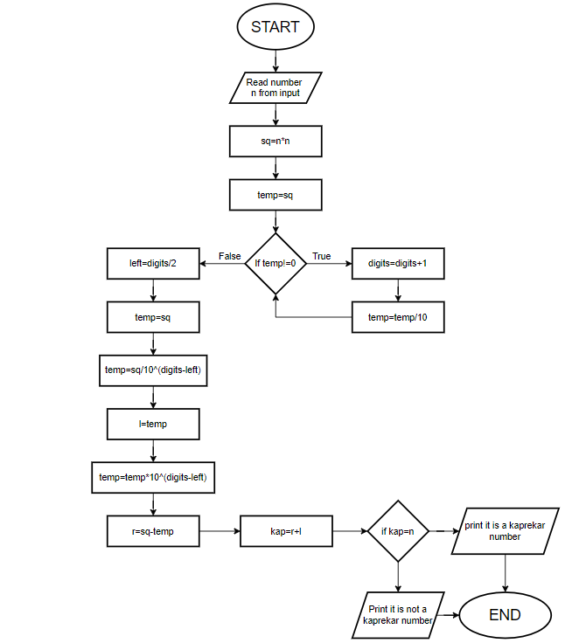
PROGRAM: | #include<stdio.h>  #include<math.h>  int main(){  int n,digits=0,sq,temp,left,l,r,kap;  printf("Enter a positive number\n");  scanf("%d",&n);  if(n<=0){  printf("invalid input");  return 0;  }  sq=n*n;  temp=sq;  while(1){  if(temp!=0){digits++;}  else{break;}  temp=temp/10;  }  left=digits/2;  temp=sq;  temp=sq/pow(10,digits-left);  l=temp;  temp=temp*pow(10,digits-left);  r=sq-temp;  kap=r+l;  if(kap==n){  printf("%d is a Kaprekar number",n);}  else{printf("%d is not a Kaprekar number",n);}  return 0;  }
RESULT: 